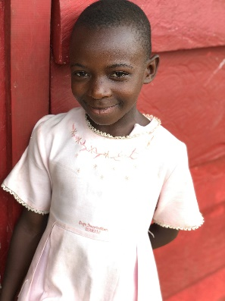
(Insert date)
Dear Friends and Family,
I am writing today to tell you about an unexpected journey that I am about to embark upon. Over the recent past, a series of events opened my eyes to an extraordinary opportunity, and I am writing to ask you to join me in being part of something quite special.
I was introduced to an organization called Hearts & Hope for Uganda. They partner with several churches and send mission teams to various villages in Uganda, Africa. Over the years, various church congregations have established a close relationship with the people of rural Uganda in these villages. They have installed water wells, built new school buildings, and have sponsored over 800 children to go to school. Each summer, sponsors go to these villages with Hearts & Hope and return changed forever. The widows and orphans of these villages have motivated members of congregations to give generously to this village and to Hearts & Hope. It has truly been an amazing thing to witness.
I have experienced an undeniable calling through quiet, internal whispers and audible, external voices to use my God-given gifts in a unique way: To witness first-hand this story of two very different communities partnering to change the world. To share in the many stories I’ve heard of lives that have been changed here the U.S. and those that have been changed on the other side of the world in Uganda.
In order to really be able to fulfill this deep desire and share this beautiful message of love and hope with you, I need to go and experience the joy of serving in Uganda, myself. And this is where I need your help.
In the next few months, I need to raise to help our family cover the expenses of this mission trip. For someone who usually likes to have a plan in place, committing to this trip without having the funds available is truly a leap of faith. It does seems crazy and impossible to raise it all, but I know that nothing is impossible for those who put their trust in the Lord.
So, how can you be part of this journey with me? The most important thing I ask for is your prayers. My family is supportive, but I don’t think I have really wrapped my head around the reality of leaving them to travel to Africa. Please pray for the team that are going and for the people we will serve. The date of the trip is . I will be ready to share about the entire experience from beginning to end with pictures and stories, so you can feel like you’ve been with me all along and experienced it with me. Finally, if you feel led to help me financially, I would be forever grateful. Whether through prayers or financial support, you will become a part of this amazing story.
If you feel called to help me with this effort, please send a note using the form on this page, so that I can take your words, prayers, and encouragement with me. If you can support me financially, please write a check to Hearts & Hope in the amount of your gift and send it to me at my home address listed on the form. Any gift over $25 is fully tax-deductible. You will receive a receipt from the organization for that purpose. Thank you from the bottom of my heart for considering how you can join me in this life-changing mission.
With Much Love and Trust in Him,
(signature)

Please write me a message below letting me know how you would like to support me on this journey! I would love nothing more than to carry your words with me. Please return by if at all possible to my home address below. I know that is soon! If you can’t meet that deadline, please know that your gift will still be appreciated whenever you can give for a future trip. Thank you, thank you, and thank you again!
Name:
Address:
Email:
I would like to support (insert name) in this mission by:
☐ Praying
☐ Giving a financial donation of $_______________

Provide a message to (Insert Name) here:

Please return this sheet to (insert name) and include any checks (made payable Hearts and Hope) by the date above if at all possible. You can also donate online at www.heartsandhope.org, click on the donate tab and scroll to trip donations- it’s that easy!
My Home address is:

