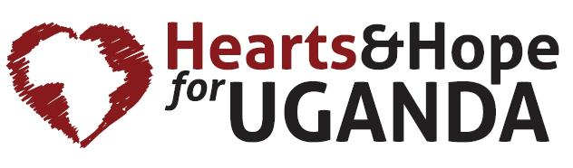
Uganda Mission Trip
Finance Form

Your non-refundable deposit/plane fare will be due by . You will receive an invoice that will allow you to pay online. Any donations provided by others to support you should be checks made payable to “Hearts & Hope” or they can be made through our website.
Refunds:
Because Hearts & Hope is a tax-exempt nonprofit organization, the Internal Revenue Service will not allow us to “refund” any contributions. Therefore Hearts & Hope cannot refund any payments made for mission trips. Your trip payment (regardless of who wrote the check) is actually a contribution which is pooled into a Team budget. Each Team budget remains under the full control and authority of Hearts & Hope, and is used specifically for all expenses related to the given Team’s intended purpose.

Cancellations:
A person who has to cancel for legitimate reasons (e.g. medical or family emergency) does have the option to apply their payment amount to a future Hearts & Hope Mission Team, or to designate another person to go in his/her place on the current Team (both options available for the twelve months from the date of the original Team’s departure.)

Print Name: _______________________________________

Team Member Signature:__________________________________ Date: ___________

