Hearts & Hope is a 501c3 nonprofit so your donation is tax deductible!

What?
Hearts & Hope’s 10th Annual Party with a Purpose – This annual event is the only fundraising event for Hearts & Hope and ensures that our vision becomes a reality!
Who?
Hearts & Hope is a St. Louis-area 501c3 nonprofit focused on transforming poor villages in Uganda through clean water, health & wellness, education, and small business development. Since its founding in 2011, Hearts & Hope has established 8 schools which provide education to over 2,000 children!
Why?
Hearts & Hope has experienced exponential growth in the last few years during which we have expanded into new regions, added new partners & villages and hired additional staff. To continue with this rate of growth Hearts & Hope needs help funding the mission.
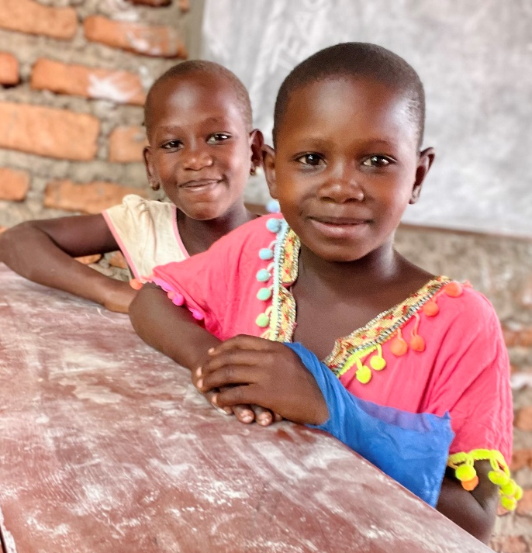

How Can I Help?
Donate merchandise or service for the auction! Donate a Gift Certificate for a product or service! Have a condo that you’d be willing to offer for a weekend? Become an Event Sponsor – You’ll receive advertising in our event program, social media exposure, tickets to the event, and more.

Donations are tax deductible – all merchandise or services donated will feature your business’ name prominently.

Thank You for your Donation to Hearts & Hope’s  10th Annual Party With a Purpose! |  |  |  | 3000 Imperial Drive  Saint Peters MO 63303
Item Description
Est. Value | $
Name
Email |  |  | Phone
